ICCP
COMMISSION I
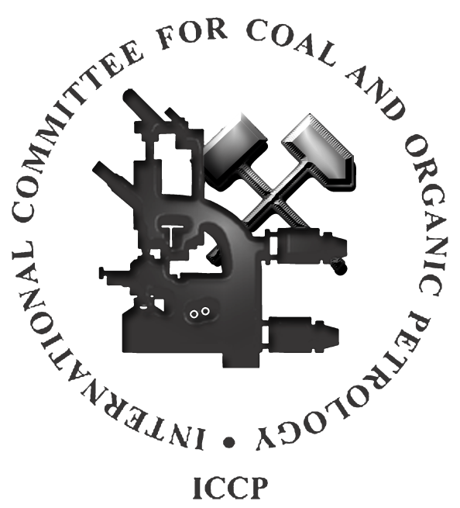

Radiolytic alteration of organic matter
in coal and rocks enriched in radioactive minerals

2023 ROUND ROBIN EXERCISE

Convenors: Dr. Tatiana Larikova, Dr. Ivana Sýkorová (Czech Republic),
Dr. Stavros Kalaitzidis (Greece)

e-mail: larikova@irsm.cas.cz

Prague, Czech Republic, April 2023
1. Introduction

The Radiolytic alteration Working Group was established during the 73d ICCP Meeting in New Delhi (India) in 2022. The respective information about the established working group was published in the ICCP News Letter No. 84, 2023.

The aims of the Radiolytic alteration Working Group are:

1) Petrological identification and definition of microscopical textures of radiolytic alteration of organic matter (bitumens, coal macerals, dispersed organic matter) with potential suitability for the ICCP Classification;
2) To determine the basic types of the bright areas around radioactive minerals: halos, bright zones around cracks and veins, and the others. On this base, the system of distinct optical structures will be developed.
3) To determine the range of (critical) uranium concentrations at which the degradation processes of organic matter begin to appear, resulting in increasing light reflectance and formation of zones around radioactive minerals;

2. Objective of the 2023 RAWG 1 Round Robin Exercise
The objective of the 2023 Round Robin Exercise is to determine the basic types of the bright areas around radioactive minerals: halos, bright zones around cracks and veins, and the other more complex ones.

During this exercise, participants are asked to identify the basic types of the bright areas around radioactive minerals: halos, bright zones around cracks and veins, and the others, in accordance to the suggested preliminary classification.
Secondly, participants are asked to make comments on the identified forms and on the preliminary classification.
Thirdly, if they would like, participants are asked to add their own examples with radiolytically altered organic matter.

- Preliminary classification of the bright areas around radioactive minerals
Association of uranium with the organic matter have been studied for more than ninety years: in bitumens (Ellsworth, 1928a, b; Parnell, 1993; England et al., 2001), in bituminous coal (Kříbek et al., 2017; Sýkorová et al., 2016; Eskenazy and Velichkov, 2012), in lignites (Havelcová et al. 2014; Rallakis et al., 2019), and in shales (Lecomte et al., 2017; Liu et al., 2020). Uranium minerals occur as inclusions of nanometer to micrometer size, often homogeneously dispersed in the organic matrix. The longer-lasting association of high content of U with bitumen or coal macerals lead to damage of organic matter, especially its morphology, optical properties, and composition.
Petrographic evidences of published radiolytic alteration of organic matter enriched in uranium minerals include formation of:
- bright simple or complicated circles, ellipses and irregular aureoles ‘halos’, appeared in coal macerals and bitumens around dispersed uranium minerals (Jedwab, 1966; Gentry et al., 1976, Leventhal et al., 1986; Machovič et al., 2021);
- ii) irregular and asymmetrically embossed bright areas or zones, formed along veins and cracks in organic matter filled with U-bearing minerals (Sýkorová et al., 2016; Havelcová et al., 2022); and also, bright nodular and dendritic textures with irregular morphology and mineralization (Havelcová et al., 2022);
- iii) bright massive to porous semi-coke/coke formation (Havelcová et al. 2014). During the radiolytic alteration, reflectance values of organic matter increase and fluorescence intensity decreases with increase in U concentration in uraniferous carbonaceous matter (Breger, 1974; Parnell, 1993; Smieja-Król et al., 2009; Zhang et al., 2019; Sýkorová et al., 2016, Machovič et al., 2021, Havelcová et al., 2022).

Notes:

Initially, we are going to divide the matter to minerals and organics. Minerals are divided to non-uranium and U-bearing, these, in turn, could be found as single separate grains or dispersed. That may be important in describing the morphology of the radiolytic alteration.
The organic matter will be divided to not-altered and altered radiolytically. Areas and aureoles of radiological alteration may be massive or porous, pale/weak and bright/strong, have sharp or diffused borders. By the morphology we distinguish halos (areoles) around separate U-bearing minerals, sometimes they form groups or colonies. We suppose, it may be important to note if the halos in a colony are interconnected, as interference of halos may occur.
The other, more complex, textures of radiolytic alteration of organic matter besides halos, we describe as having an irregular morphology. These textures may represent as their appearance: massive, rounded, nodular or patchy, but also the possible mechanism of their formation: dendritic, fragmented, flow or being formed along cracks and veins, filled with U-bearing minerals. By the last pattern (complex) we are going to mark the textures, which can’t be described by previous patterns.
In case if the textures of the radiolytic alteration are porous, we would like to note if they can be attributed to semi-coke or coke.

Examples:

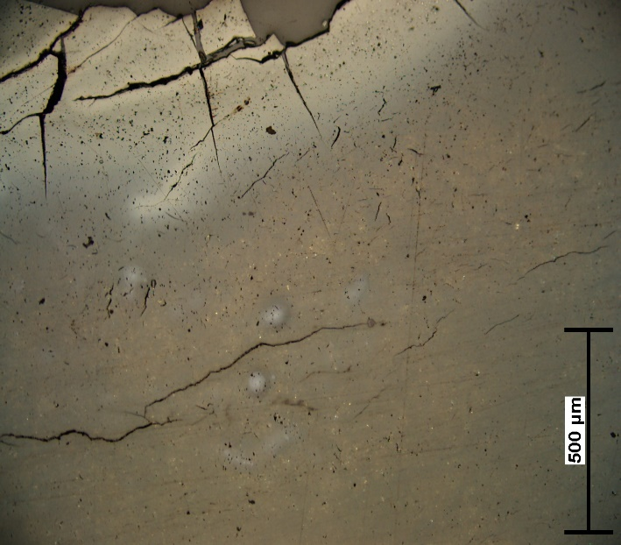  Radiolytically altered areas along the cracks, and pale halos with diffused borders around separate U-minerals in not-altered fossil resin (duxite). | 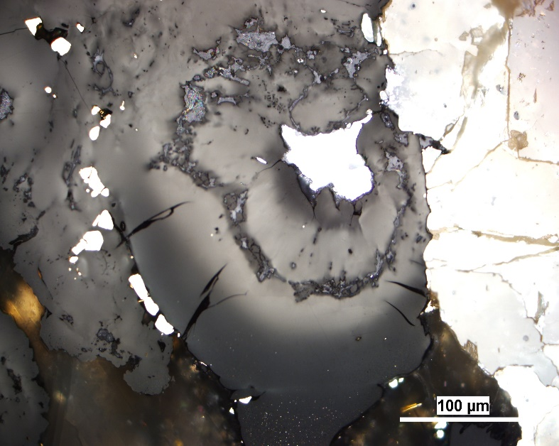  Radiolytically altered rounded aureole (halo) with diffused borders and darker inner rim around separate U-mineral in bitumen.
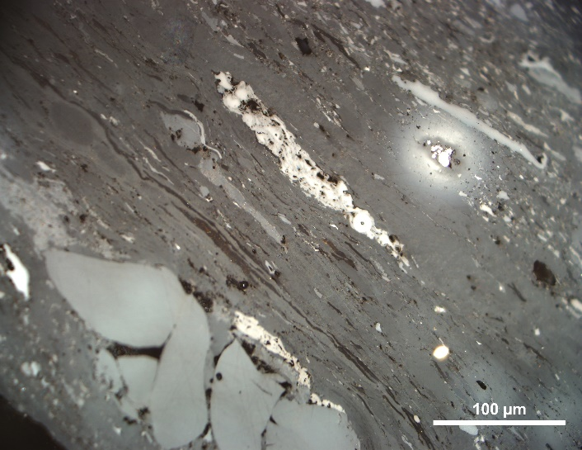 Radiolytically altered bright halos with diffused borders and darker inner rim around separate U-minerals in bituminous coal. | 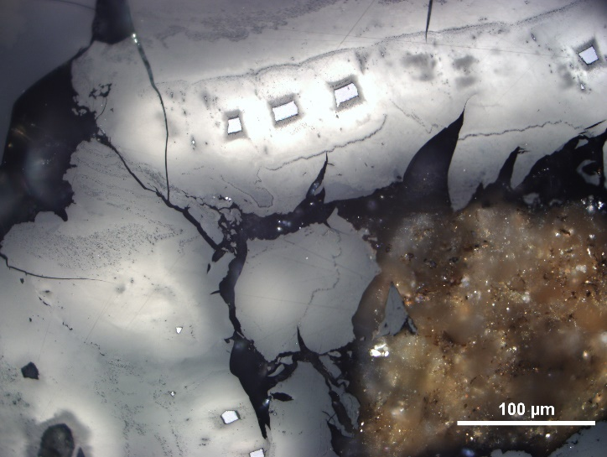  Radiolytically altered bright interconnected halos with diffused borders and darker inner rims around fragmented U-minerals in bitumens.

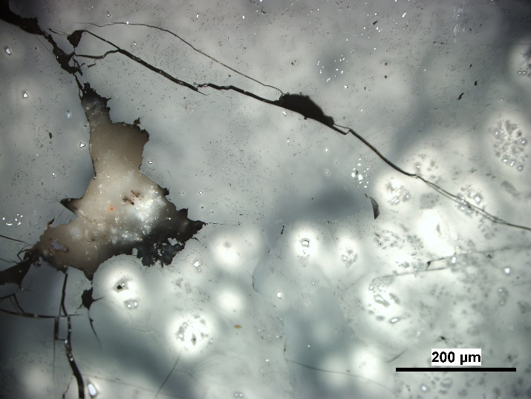  Radiolytically altered bright interconnected colony of halos with diffused borders around U-bearing minerals in bitumens with dispersed mineralization. |  | 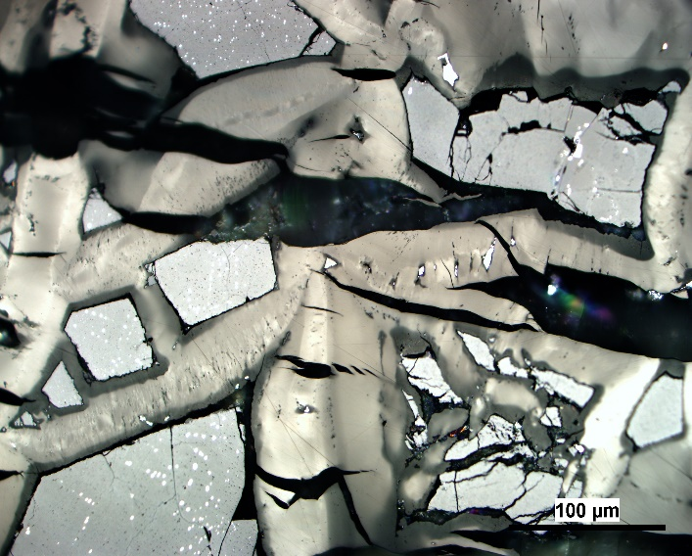  Radiolytically altered massive irregular areas with diffused borders in in bitumens, filling the fractures, containing U-bearing minerals.
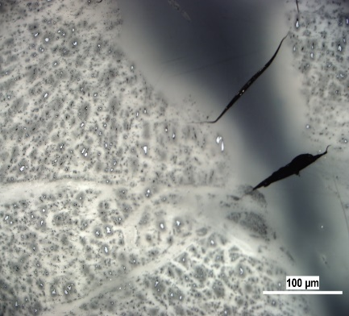  Radiolytically altered patchy interconnected colony of halos with diffused borders and darker inner rims around dispersed U-minerals in bitumens. |  | 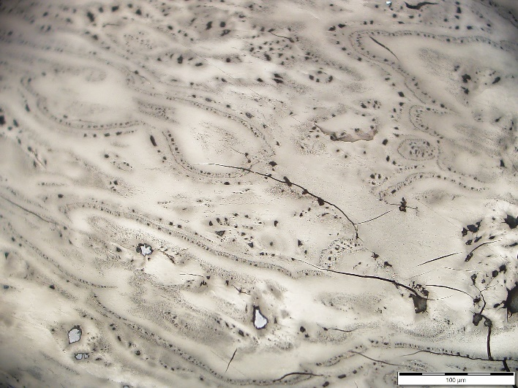  Radiolytically altered complex flow irregular texture with darker inner rims around separate U-bearing minerals.

Round Robin Exercise

The 2023 Round Robin Exercise is based on 39 slides with 96 marked areas, containing radiolytically altered organic matter from uraniferous coals and rocks with bitumen. Pictures are taken under reflected non-polarized incident white-light (RL), and/or under UV fluorescence microscopy; all of them with immersion oil, if not indicated -dry-. Some slides also contain notes on the random and mean – average reflectance values of weak and strong alteration; and bulk uranium content.

Participants are asked to determine the form of radiolytic alteration in the rectangle in accordance to the preliminary classification and mark the answer in the attached Excel file (2023_Round_Robin_Exercise_ RadAltWG.xls).

How to mark answers in the attached Excel file according to the established classification:

- In case of Level 1: Organics -Minerals, please mark one of them.
- In case of Level 2: Uranium content (low, medium, high), please mark one of them.
- In case of Level 3: Minerals: Non-Uranium – U-bearing, please mark one.
- In case of Level 4: Minerals-Uranium-bearing minerals: single grain - dispersed, please mark one.
- In case of Level 5: Organic matter: Non-Altered and Altered, please mark one of them.
- In case of Level 6: Organic matter- Altered - Intensity of radiolytic alteration: pale/weak or bright/strong, please mark one of them.
- In case of Level 7: Organic matter- Altered - Borders of altered areas (sharp – diffused), please mark one of them.
- In case of Level 8: Organic matter- Altered - Character of altered areas (massive – pores/holes), please mark one of them.
- In case of Level 9: Organic matter- Altered - Morphology of altered areas: Halo - Irregular, please mark one of them.
- In case of Level 10: Halos: single – group/colony, please mark one of them.
- In case of Level 11: Halos in group/colony: separated – interconnected, please mark one of them.
- In case of Level 12: Darker inner rim in halos; single – group/colony, please mark one of them.
- In case of Level 13: Organic matter- Altered - Irregular morphology: Massive, Along fractures/veins, Patchy, Rounded; Flow; Dendritic; Nodular; Complex, please make one or multiple.
- In case of Level 14: Semi-coke/Coke, please mark one or none of them.

Time limit for the 2023 RAWG Round Robin Exercise

It is anticipated for the participants of the RAWG Exercise 2023 to submit the results electronically by the June 30, 2023 in form of established exercise sheets to Tatiana Larikova (larikova@irsm.cas.cz).

References:
- Breger, I.A., 1974. The role of organic matter in the accumulation of uranium: the organic geochemistry of the coal-uranium association. International Atomic Energy Agency (IAEA): IAEA.
- Ellsworth, H., 1928a. Thucholite, a remarkable primary carbon mineral from the vicinity of Parry Sound, Ontario. Am. Mineral. 13, 419-441.
- Ellsworth, H., 1928b. Thucholite and uraninite from Wallingford Mine, near Buckingham, Quebec. Am. Mineral. 13, 442-448.
- Eskenazy, G.M., Velichkov, D., 2012. Radium in Bulgarian coals. Int. J. Coal Geol. 94, 296-301.
- England, G.L., Rasmussen, B., Krapež, B., Groves, D.J., 2021. The origin of uraninite, bitumen nodules, and carbo seams in Witwatersrand gold-uranium-pyrite oree deposits based on a permo-Triassic analogue. Econ. Geol., 96, 1907-1920.
- Gentry, R.V., 1976. Radiohalos in coalified wood. New evidence relating to the time uranium introduction and coalification. Science, 194, 315-318.
- Havelcová, M., Machovič, V., Mizera, J., Sýkorová, I., Borecká, L., Kopecký, L., 2014. A multi-instrumental geochemical study of anomalous uranium enrichment in coal. J. Env. Rad. 137, 52-63.
- Havelcová, M., Machovič, V., Mizera,J., Sýkorová, I., René, M., Borecká, L., Lapčák, L., Bičáková, O., Janeček, O., Dvořák, Z., 2016. Structural changes in amber due to uranium mineralization. J. Environ. Radioactiv. 158–159, 89–101.
- Havelcová, M., Sýkorová, I., René, M., Mizera, J., Coubal, M., Machovič, V., Strunga, V., Goliáš, V., 2022. Geology and petrography of uraniferous bitumens in Permo-Carboniferous sediments (Vrchlabí, Czech Republic). Minerals, 12, 544, 1-19.
- Jedwab, J. 1966. Significance and use of optimal phenomenon in uraniferous caustobioliths. In: Coal Science, Advances in Chemistry; American Chemical Society, Washington, DC.119-132.
- Kříbek, B., Sýkorová, I., Veselovský, F., Laufek, F., Malec, J., Knésl, I., Majer, V., 2017. Trace element geochemistry of self-burning and weathering of a mineralized coal waste dump: The Novátor mine, Czech Republic. Int. J. Coal Geol., 173, 158-175.
- Lecomte, A., Cathelineau, M., Michels, R., Peiffert, C., Brouand, M., 2017. Uranium mineralization in the Alum Shale Formation (Sweden): Evolution of U-rich marine black shale from sedimentation to metamorphism. Ore Geol. Rev., 88, 71-98.
- Leventhal, J.S., Daws, T.A., Frye, J.S., 1986. Organic geochemical analysis of sedimentary organic matter associated with uranium. Appl. Geochem., 1, 241-247.
- Liu, B., Mastalerz, M., Schieber, J., Teng, J., 2020. Association of uranium with macerals in marine black shales: Insights from the Upper devonian New Albany Shale, Illinois Basin. Int. Coal Geol., 217, 103351.
- Machovič V., Havelcová M., Sýkorová I., Borecká L., Lapčák L., Mizera J., Kříbek B., Krist P., 2021. Raman mapping of coal halos induced by uranium mineral radiation. Spectrochimica Acta Part A: Molecular and Biomolecular Spectroscopy 246, 2021; 118996.
- Parnell, J., 1993. Chemical age dating of hydrocarbon migration using uraniferous bitumens, Czech-Polish Border Region. In J. Parnell et al. (eds). Bitumens in Ore Deposits. Springer-Verlag Berlin - Heidelberg, 510-517.
- Rallakis, D., Michels, R., Brouand, M., Parize, O., Cathelineau, M., 2019. The role of organic matter on uranium precipitation in Zoovch Ovoo, Mongolia. Minerals, 9, 310.
- Smieja-Król, B., Duber, S., Rouzaud, J.-N., 2009. Multiscale organisation of organic matter associated with gold and uranium minerals in the Witwatersrand basin, South Afrika. Int. J. Coal Geol. 78, 77-88.
- Sýkorová, I., Kříbek, B., Havelcová, M., Machovič, V., Špaldoňová, A., Lapčák, L., Knésl, I., Blažek, J., 2016. Radiation- and self-ignition induced alterations of Permian uraniferous coal from the abandoned Novátor mine waste dump (Czech Republic). Int. J. Coal Geol. 168, 162–178.
- Taylor, G.H., Teichmüller, M., Davis, A., Diessel, C.F.K., Littke, R., Robert, P., 1998. Organic Petrology. Gebrüder Borntraeger, Berlin-Stuttgart.
- Zhang, F., Jiao, Y., Wu, L., Rong, H., Wang, L., Zhang, Z., 2019. In-situ analyses of organic matter maturation heterogeneity of uranium-bearing carbonaceous debris within stones: A case study from the Ordos Basin in China. Ore Geology Reviews, 109, 117-129.

