Title (Arial, 12pt, bold, single line spacing, left aligned)

A. Author*¹ (Author, Arial, 10pt, single line spacing, left aligned)

¹ University “Politehnica” Bucharest, 1 Polizu St., 011061, Bucharest, Romania
* e-mail: a.author@upb.ro
(Affiliation, Arial, 10pt, single line spacing, left aligned)

Abstract
(Arial, 11pt, single line spacing, justified)

Page Setup: It is strongly recommended to keep this given paper format. We kindly advice you to input your paper text in this document which is already properly formatted, following the information of Guidelines for Abstracts.

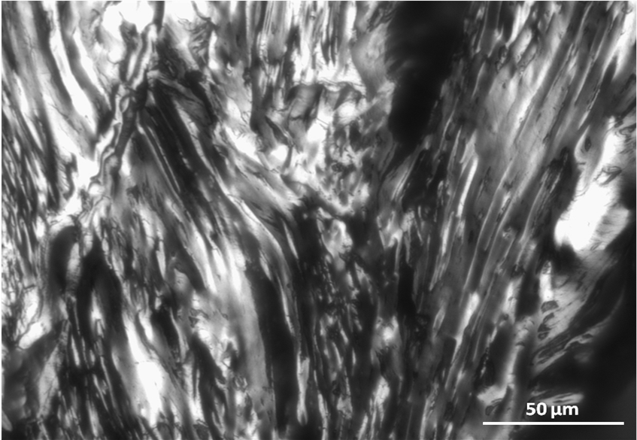

Fig. 1: (Arial, 10pt, single line spacing)

Acknowledgements:
(Arial, 10pt, single line spacing, justified)
This section is optional.
References:
(Arial, 10pt, single line spacing, justified)
Panaitescu, C., Predeanu, G., 2007. Microstructural characteristics of toluene and quinoline-insolubles from coal-tar pitch and their cokes. Int. J. Coal Geol. 71, 448–454.

