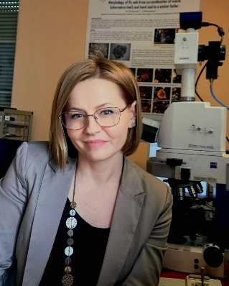
Małgorzata Wojtaszek-Kalaitzidi is a Chemical Technology Engineer; she received her Ph.D. in 2015 from AGH University of Science and Technology in Cracow, Poland.
Małgorzata has over 16 years of R&D experience in cokemaking technologies, solid fuels and wastes quality assessment, as well as Organic Petrology of fossil fuels, carbon materials and wastes. Both, her master thesis and doctoral dissertation were focusing on the field of Cokemaking Technology. Małgorzata is working at the Institute of Energy and Fuel Processing Technology (ITPE) since 2007. Her whole scientific career is related to raw materials quality assessment and processing technologies.
Dr. Wojtaszek-Kalaitzidi specializes in assessing quality of coking coals from Polish mines, as well as imported from all over the world, being used by Polish and European cokemaking industry. She cooperates with Polish scientific institutions and industry as well as European Universities and Coking Plants providing training courses and lectures. From 2010 she is a member of the International Committee for Coal and Organic Petrology (ICCP). Małgorzata became the convener of the Coke Petrography WG in 2013 and co-convener of The Microscopy of Carbon Materials WG in 2018. She is also the organizer of the ICCP Accreditation Program in Coal Blends. Apart from these, she is the representative of ITPE in Polish Standardization Committee (PKN) in Technical Committee no. 220: Natural Solid fossil fuels and a member of Polish Carbon Society and TSOP.
In everyday work Małgorzata focuses on studying the optical properties and their influence on the processing technologies of coal in whole range; chars of various materials including wastes from automotive, constructions, furniture; coke; coke with various additives including, i.e. plastics, coal tar, catalysts; biocoke/biochars; electrode material; fly ash; slug; pitch; petcoke; mesophase; thermally and chemically altered coal; biomass & biomass wastes; torrefied biomass, environmental samples.
Her research portfolio includes more than 30 articles published in peer-reviewed journals, 3 monographies and 2 patents, which received more than 110 citations in Scopus (h-index 7).

My Vision as Secretary of Com III
Commission III deals with very important subjects, the effects of which support the industry throughout the entire technological process; meaning from quality control of raw materials, through semi-finalised and finalized products, to the assessment of the impact of the processes and products on the environment. My vision as Secretary of Commission III concerns primarily supporting the Chair, as well as motivating the Members in developing and participating in WG activities, aiming at creating tools applying Organic Petrology methods, which will support the needs of the industry in the current fragile transition period. Industrial transformation and decarbonization involve moving away from the use of fossil fuels with the simultaneous emergence of new types of materials and wastes, to where Organic Petrology can successfully contribute.

